Does Patient Experience Affect Length of Stay
Dillon T. Isaacson
Western Governors University

David Gagner
D208
4/05/2021

Abstract
In the medical industry, patients expect to have high quality care and ideally they are not coming back anytime soon. With that in mind, we can ask for their feedback regarding their care and track if they are readmitted or not. The question I would like to investigate is if we can use their feedback regarding the quality of their care to see if that affects the length of their initial stay in days. We have eight feedback points ranked on a scale of 1 to 8 (1 being least important and 8 being most important) for how important they felt those items were regarding their care.

Does Patient Experience Affect Length of Stay
Part One
What do People Think
The question I want to investigate is if the feedback of how important items are for a patient will affect the length of their initial stay. The data we have been given for this has already been cleaned, so I don’t have to do anything more to clean the data. I will do some manipulation of the data to create a test set and a training set. I have my mind set on doing a linear regression for this analysis. I’m choosing a linear regression because when considering doing a linear or logistic regression I feel doing the linear is a little more straightforward. The response variable, the length of initial stay, is not a binary response so a logistic regression is also a poor fit. No data set is naturally perfect for doing a linear regression. We can assume normality of the data given the size of the data set because with 10,000 entries we satisfy the Central Limit Theorem.
I do have an important decision of what technology to use. I have more experience doing linear regressions in R so that is what I’m going to be using. I also know the packages that allow me to manipulate the data and select just the columns I’m wanting to work with easily and smoothly. I mentioned the Central Limit Theorem before, and I do so to address the assumptions that must be met to test using a linear regression. Another reason I’m choosing to use R is that gives an easy output to visualize those assumptions and check how well they are being met. I’m not concerned about them, but it will be good to know how they look. Those assumptions are that there is a linear relationship, multivariate normality exists, there is no or little multicollinearity, no autocorrelation, and checking for homoscedasticity.
I will be doing a multiple linear regression for this test so I can check all the variables against the length of stay. This is important because checking them one at a time may show that multiple variables are linearly related, but I want to know how all of them are impacting the length of stay. By checking all these variables at once, I can see how they all contribute at once and see if any of the variables aren’t necessary for the analysis to try and simplify the model as I go. While in excel, I did a quick check for any missing values in the data I will be using, and I found none.
One final step I would like to take before diving into this analysis is just to look at the distribution of these variables in terms of their five-number summaries, I have created a sample set to test with consisting of 7000 of the 10000 entries. The snips of those are included in the following figures. Figure 1 is the five-number summary of the initial stay, Figure 2 is items 1-4 in that order, and Figure 3 is items 5-8 in that order.
Figure 1

Figure 2
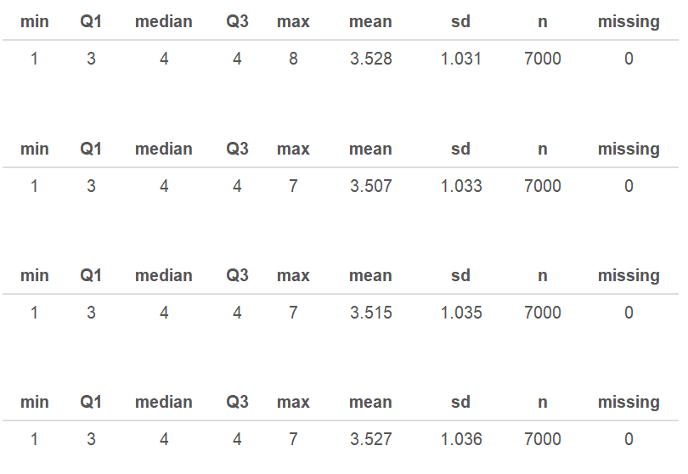
Figure 3
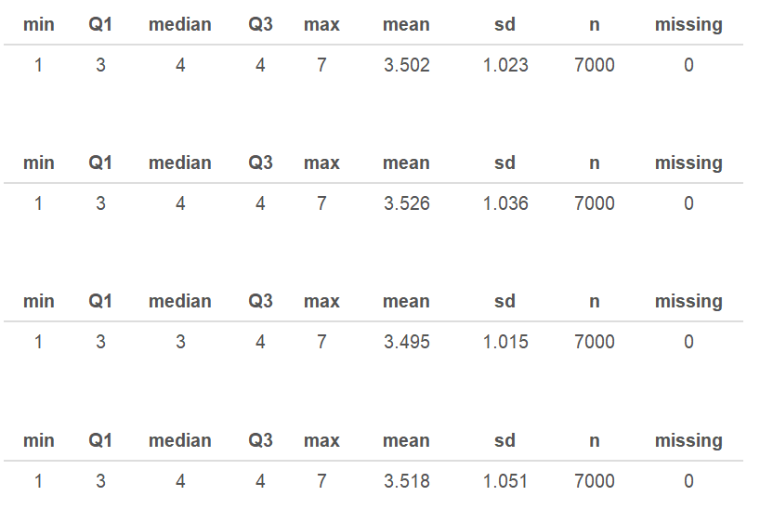
Looking at all of these quickly, Item 7 has the smallest standard deviation as well as the smallest mean.
Part Two
An Analysis
I said before that I’m going to be doing a multiple linear regression. I’m choosing to use α = .10, this is a little higher α value than what some people may choose. I have concerns about how well this data will fit the assumptions for doing a regression so I’m going to expand my tolerance for this test. I’m electing to ignore the assumptions for regression at this time due to the size of the data set because like I said before the size of the data set allows for some degree of freedom to perform an analysis without everything being perfect. Figure 4 shows the results of the initial regression and Figures 5, 6, and 7 show the charts addressing the appropriateness of the regression.
Figure 4
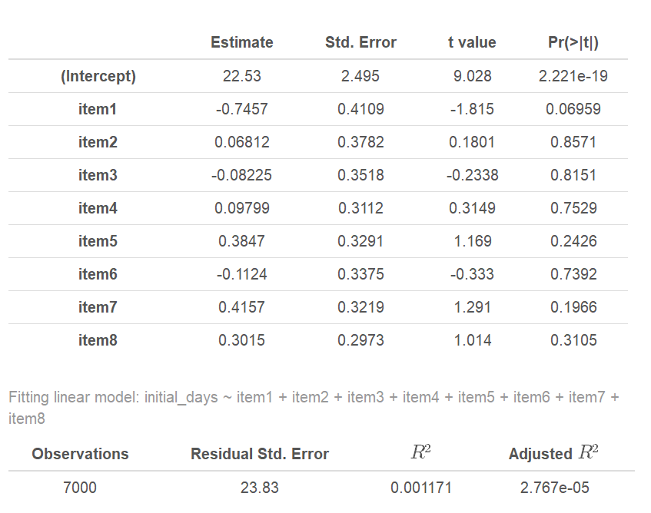

Figure 5
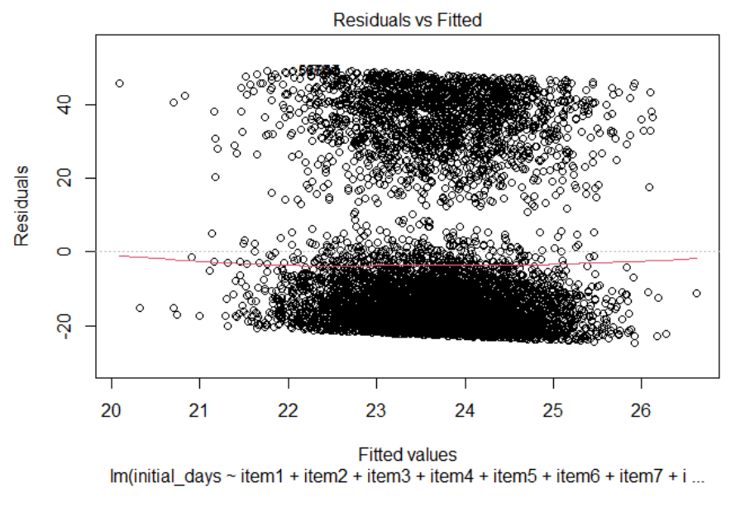
Figure 6
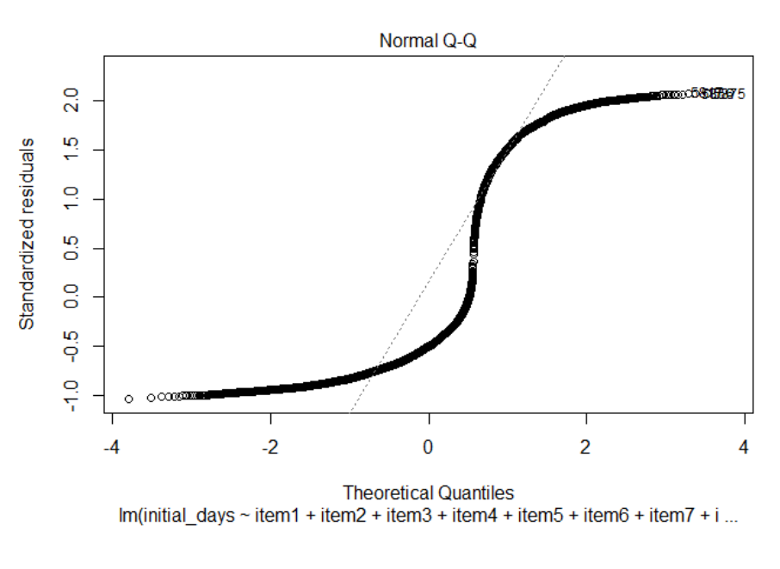

Figure 7
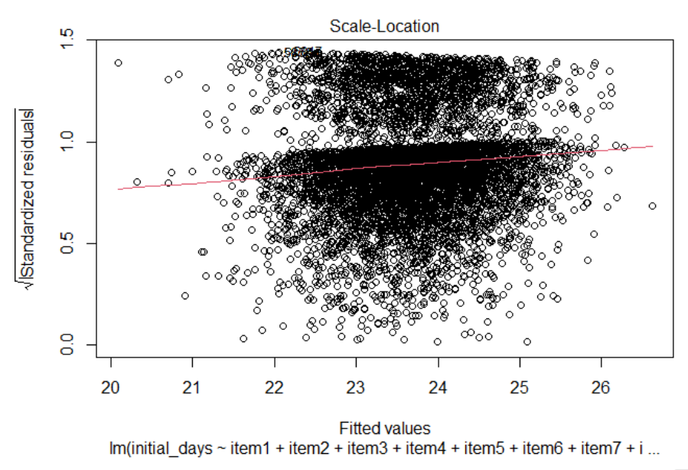
Looking at all of these output, the model is an incredibly poor fit. Normality really isn’t there, the residuals don’t appear to be too bad, but the R² is really low as well. So with that in mind, we do have one variable that is working and predicting the model and that’s Item 1, Timely Admission. So, there does appear to be a correlation between patients feeling Timely Admission is important and that they got that and the length of their initial stay.
I’d like to reduce the model and take some of the variables out. The two variables I’m choosing to remove are Items 2 and 3, Timely Treatment and Timely Visits. These two have the highest p-value so I feel they are the least likely to begin contributing to the model in a reduced form. Figures 8-11 are the outputs of this reduced model.

Figure 8
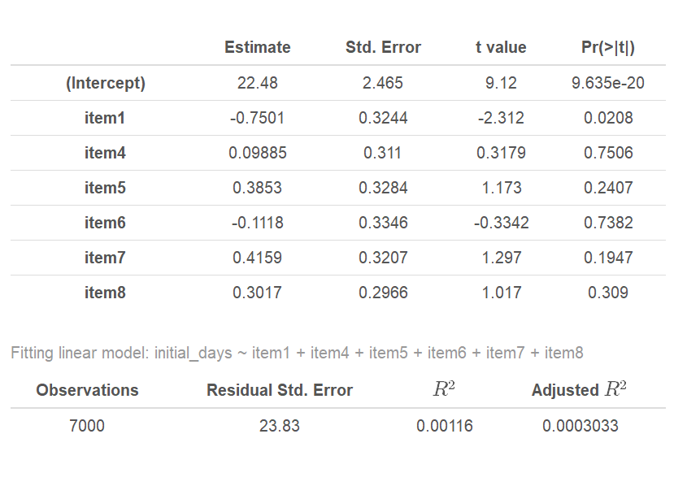
Figure 9
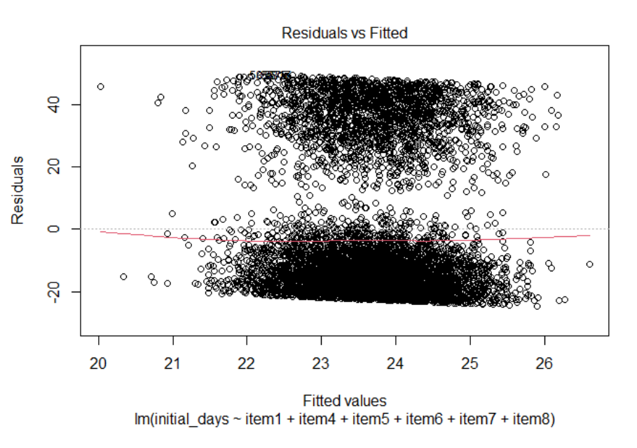

Figure 10
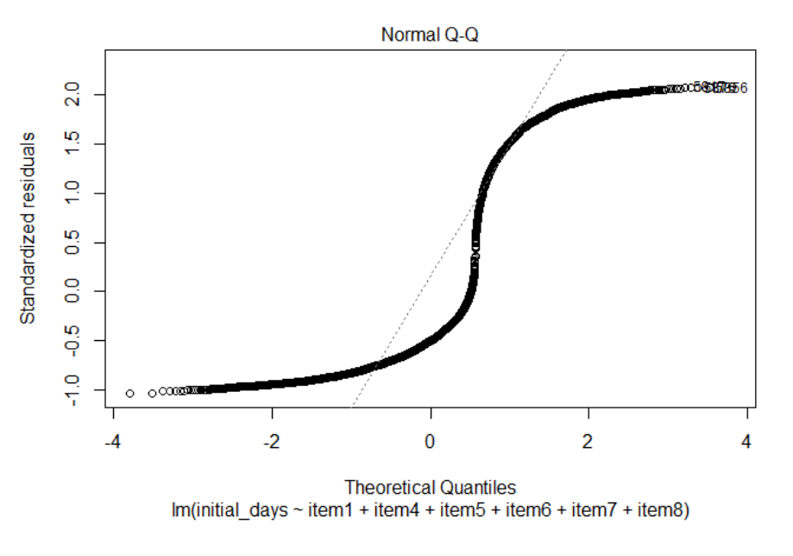
Figure 11
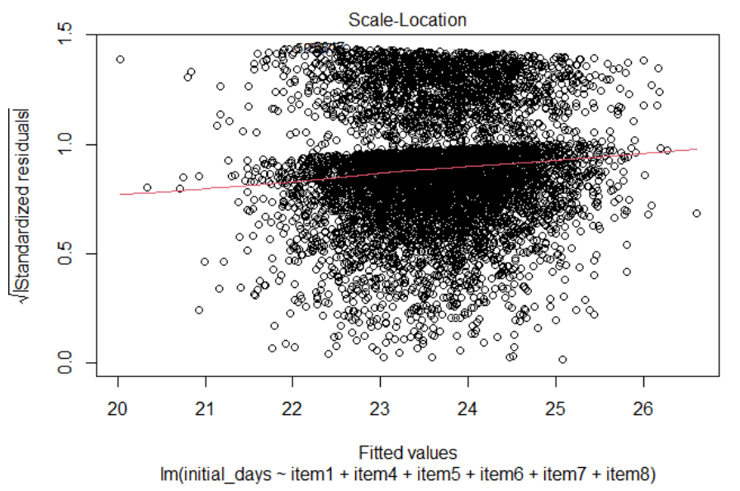
This is very similar to the previous model, our R² has actually gotten a bit worse however but the p-value for Item 1 has fallen below 0.05 which is great to see. Other p-values have improved, but none to a degree of significance where I can accept them at this time. Doing more iterations of this may eventually yield a second significant variable but I don’t know for sure that it that is true.
The finaly model that I would recommend following is shown in Figure 12. I chose to include Item 7, a Courteous Staff, because looking at the reduced model I feel that enough of a reduction would show that that variable is significant to the model, this being a coureous staff.
Figure 12

All of this said, my ultimate recommendation would be to make sure people enoy their visit. I’m sure no one wants to be waiting to be seen by their doctor for an hour plus so a study into how quickly patients are being taken back and admitted may be in order. Also, constant feedback and improving on the bedside manner of the staff if there are any issues. Doing these and seeing how it impacts the length of the initial stay of all patients would be the next step. Further analysis could be done as well to see if there is any impact on the readmission rate of patients who are getting a first glance at the new practices and procedures.

